# **Detailed Design: Fatty Liver Classification Model**

## **1. System Architecture**

The project follows the **MVC (Model-View-Controller)** architecture:

### **Model:**

* Manages liver histology image data, trained ML models, and classification algorithms.
* Processes and analyzes image data.
* Classificats NAFLD according to 4 levels. (rather use regression than classification if possible).

### **View:**

* GUI that allows users- doctors to upload images.
* Displays classification results.

**Controller:**

* Connects the Model and the View.
* Handles image input, triggers the ML model, and updates the GUI with results.

### **Data Storage:**

* Images stored in TIFF format, processed into JPG or PNG for ML use.
* Labels and metadata stored in google collab.
* Trained ML models stored for reuse.

**Architecture Diagram-**

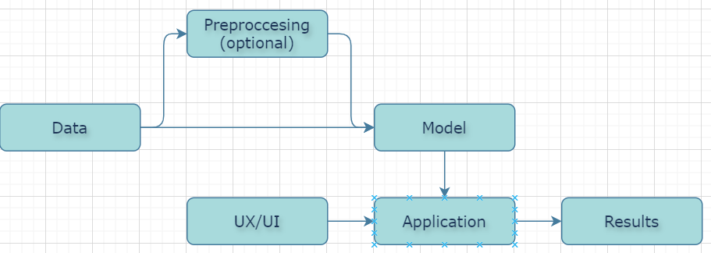

**Component Diagram-**

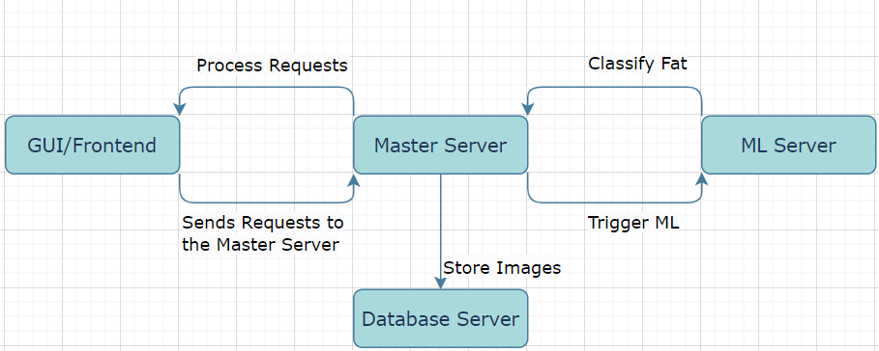

**Technology Stack Selection**:

* GUI/Frontend: React or Angular.
* Backend: Django.
* ML Framework: Python.
* Database: PostgreSQL or MongoDB.

## **2. Detailed Design**

**Use Case Diagram-**

## 

**Database schema design-**

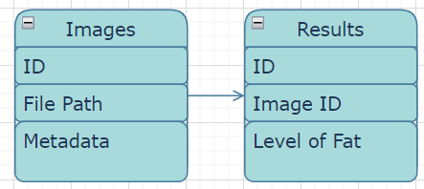

## **User Interface:**

1. **Features:**
   * Upload histology images (TIFF/JPG/PNG).
   * Display predicted fat content level.
   * Allow batch uploads and display results as a summary.
2. **Tools:**
   * **GUI Framework:** Tkinter or PyQt.
   * **Backend Framework:** Flask or FastAPI.
3. **Output:**
   * Classification results with confidence scores.
   * Option to export results in CSV format.

## **3. Data Description**

### **Dataset:**

* Liver histology images categorized into four fat content levels: low, medium, high, very high.

### **Features:**

* Images in high resolution.
* Labels for each image indicating fat content level.
* Images can be resized and normalized for training.

### **Tools:**

* Aperio software for initial image analysis and format conversion: Aperio ImageScope.

### **Model Selection:**

1. **EfficientNet:**
   * Pre-trained on ImageNet; high accuracy with low computational cost.
2. **ResNet:**
   * Deep residual networks effective for feature extraction.
3. **YOLO:**
   * Suitable if segmentation is needed for identifying specific fat regions.